Before you start, please double click on the line above and put your name. Once you finish filling out this document, save it as a PDF. You will submit this document directly to Gradescope.

On the page below, type out an explanation of what you have done. Specifically, explain how you have gone above and beyond the rubric for this assignment and tell me in detail why you believe that work is worthy of an A. Your explanation should be about a paragraph in length and should include links to material you referenced while you were creating the web page.

In this project I implemented multiple pages and CSS animations which I learned how to do from this [site](https://codepen.io/EvyatarDa/pen/waKXMd) in addition to the references from w3 schools. The animations are pull right text highlights that are used for navigations panel. I also made the navigation panel’s position static so that way it doesn’t move while the user scrolls through the page. Another thing that I thought was cool is that if posts are separated by a div tag it will put a white background around the block of text and then give it a shadow so it looks like its floating above the background image ( which is also static). The reason why I did this is because I started to learn node.js and learned enough to have it serve static web pages like this and I was thinking that I was possible to have a user just define what’s in a div tag and then just append that to inside the body tag. The only roadblock I encountered is that it wouldn’t serve the CSS page either so I just didn’t include it.

Paste a copy of your HTML document on the page below:

Index

<!DOCTYPE html>

<html lang="en">

<head>

<meta charset="utf-8" />

<meta name="viewport" content="width=device-width, initial-scale=1">

<meta name = "author" content="David Fitzgerald">

<link rel="stylesheet" type="text/css" media="screen" href="main.css" />

<title>Welcome!</title>

</head>

<body>

<div class="David">

<a href="index.html">DAVID</a>

</div>

<div class = "Header">

<p>FITZGERALD</p>

</div>

<div>

<ul class="navbar">

<li class="highlight"><a href="contact.html">contact</a> </li>

<li class="highlight"><a href="index.html">home</a></li>

<li class="highlight"><a href="blog.html">blog</a></li>

<li class="highlight"><a href="projects.html">projects</a></li>

<li class="highlight"><a href="art.html">art</a></li>

<li class="highlight"><a href="music.html">music</a></li>

</ul>

</div>

<div class="body-content">

<div>

<p> Hello all!</p>

<p>This website is dedicated for all of the content that I produce. </p>

<h3>What I make:</h3>

<ul>

<li>Game ideas or WIPs</li>

<li>Photography</li>

<li>Art</li>

<li>Web Comic</li>

</ul>

</div>

</div>

</body>

</html>

Music Page

<!DOCTYPE <!DOCTYPE html>

<html>

<head>

<meta charset="utf-8" />

<title>Music</title>

<meta name="viewport" content="width=device-width, initial-scale=1">

<link rel="stylesheet" type="text/css" media="screen" href="main.css" />

</head>

<body>

<div class="David">

<a href="index.html">DAVID</a>

</div>

<div class = "Header">

<p>FITZGERALD</p>

</div>

<div>

<ul class="navbar">

<li class="highlight"><a href="contact.html">contact</a> </li>

<li class="highlight"><a href="index.html">home</a></li>

<li class="highlight"><a href="blog.html">blog</a></li>

<li class="highlight"><a href="projects.html">projects</a></li>

<li class="highlight"><a href="art.html">art</a></li>

<li class="highlight"><a href="music.html">music</a></li>

</ul>

</div>

<div class="body-content">

<div>

<h1>THIS PAGE IS UNDER CONSTRUCTION</h1>

</div>

</div>

</body>

</html>

Projects Page

<!DOCTYPE <!DOCTYPE html>

<html>

<head>

<meta charset="utf-8" />

<title>Projects</title>

<meta name="viewport" content="width=device-width, initial-scale=1">

<link rel="stylesheet" type="text/css" media="screen" href="main.css" />

</head>

<body>

<div class="David">

<a href="index.html">DAVID</a>

</div>

<div class = "Header">

<p>FITZGERALD</p>

</div>

<div>

<ul class="navbar">

<li class="highlight"><a href="contact.html">contact</a> </li>

<li class="highlight"><a href="index.html">home</a></li>

<li class="highlight"><a href="blog.html">blog</a></li>

<li class="highlight"><a href="projects.html">projects</a></li>

<li class="highlight"><a href="art.html">art</a></li>

<li class="highlight"><a href="music.html">music</a></li>

</ul>

</div>

<div class="body-content">

<div>

<h1>THIS PAGE IS UNDER CONSTRUCTION </h1>

</div>

</body>

</html>

Contact page

<!DOCTYPE <!DOCTYPE html>

<html>

<head>

<meta charset="utf-8" />

<title>Contact</title>

<meta name="viewport" content="width=device-width, initial-scale=1">

<link rel="stylesheet" type="text/css" media="screen" href="main.css" />

</head>

<body>

<div class="David">

<a href="index.html">DAVID</a>

</div>

<div class = "Header">

<p>FITZGERALD</p>

</div>

<div>

<ul class="navbar">

<li class="highlight"><a href="contact.html">contact</a> </li>

<li class="highlight"><a href="index.html">home</a></li>

<li class="highlight"><a href="blog.html">blog</a></li>

<li class="highlight"><a href="projects.html">projects</a></li>

<li class="highlight"><a href="art.html">art</a></li>

<li class="highlight"><a href="music.html">music</a></li>

</ul>

</div>

<div class="body-content">

<div>

<h1>Contact Information</h1>

<ul>

<li>Email: davidwfitzgerald99@gmail.com</li>

<li>Twitter: you dont need to know my twitter</li>

<li>Instagram: <a href="https://www.instagram.com/dankerprouduct/"> dankerprouduct2 </a></li>

<li>Soundcloud: <a href="https://soundcloud.com/david-fitzgerald-19/sets/songs-from-my-room">Click Me!</a></li>

</ul>

</div>

</div>

</body>

</html>

Blog Page

<!DOCTYPE <!DOCTYPE html>

<html>

<head>

<meta charset="utf-8" />

<title>Blog</title>

<meta name="viewport" content="width=device-width, initial-scale=1">

<link rel="stylesheet" type="text/css" media="screen" href="main.css" />

</head>

<body>

<div class="David">

<a href="index.html">DAVID</a>

</div>

<div class = "Header">

<p>FITZGERALD</p>

</div>

<div>

<ul class="navbar">

<li class="highlight"><a href="contact.html">contact</a> </li>

<li class="highlight"><a href="index.html">home</a></li>

<li class="highlight"><a href="blog.html">blog</a></li>

<li class="highlight"><a href="projects.html">projects</a></li>

<li class="highlight"><a href="art.html">art</a></li>

<li class="highlight"><a href="music.html">music</a></li>

</ul>

</div>

<div class="body-content">

<div>

<h1>THIS PAGE IS UNDER CONSTRUCTION</h1>

</div>

</div>

</body>

</html>

Paste a copy of your HTML validation on the page below:

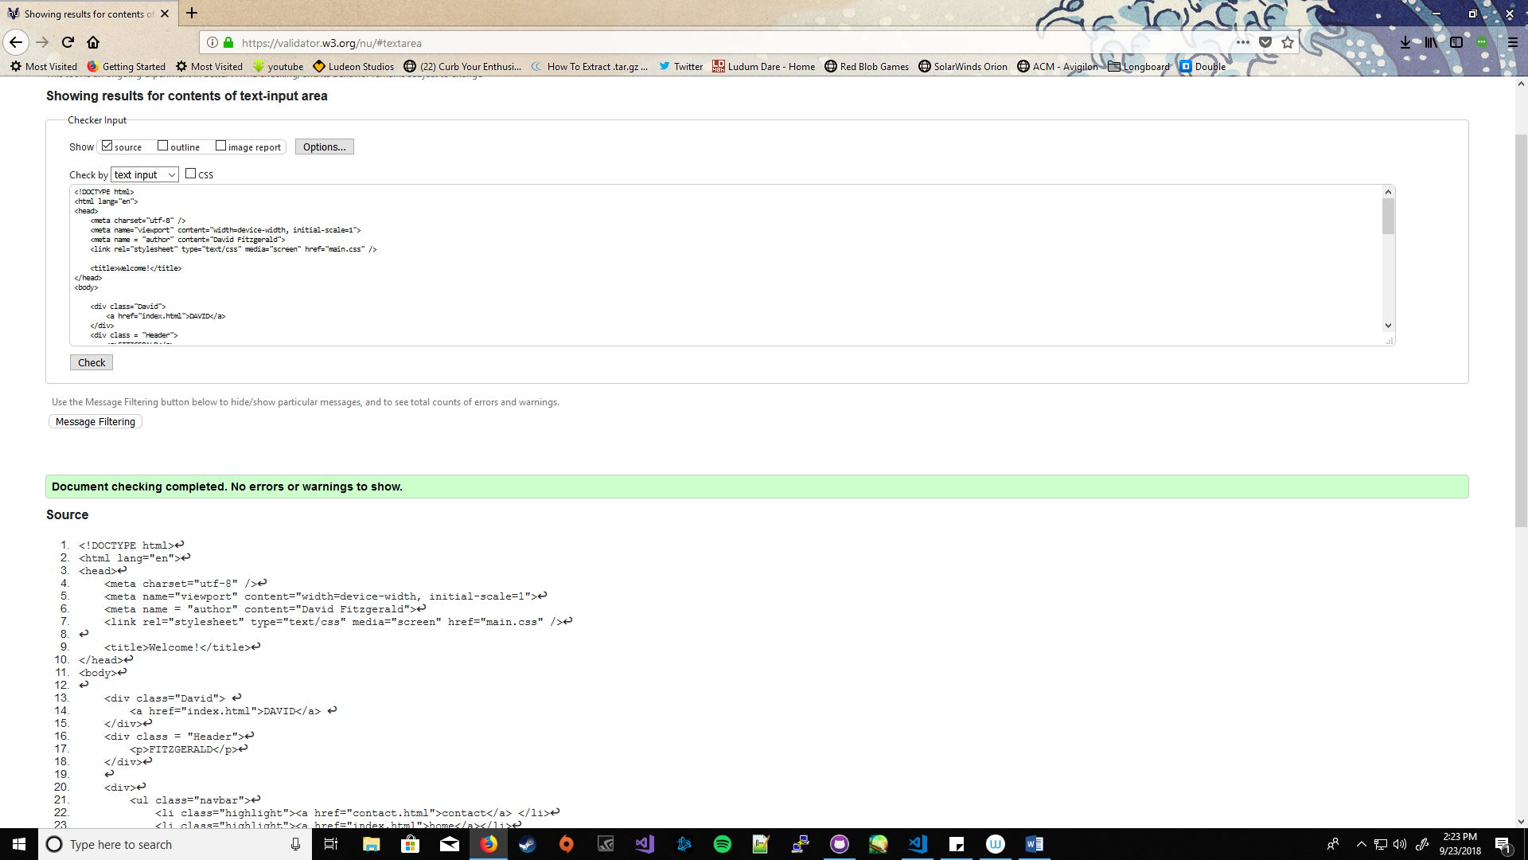

Paste a copy of your CSS on the page below:

body{

background-color: white;

font-family:Calibri;

line-height: 1.6;

font-size: 14px;

position: relative;

color: black;

text-decoration-style:solid;

background-image: url("alg.JPG");

background-attachment: fixed;

background-size: 1920px 1080px;

}

.David{

font-weight: normal;

position: fixed;

top: 10px;

left: 10px;

font-size: 26px;

letter-spacing: .8em;

color: darkgoldenrod;

display: block;

}

.David a{

text-decoration: none;

color: darkgoldenrod;

display: block;

}

.David a:hover{

color:black ;

border-bottom: 0;

text-decoration: none;

display: block;

}

.Header{ /*Fitzgerald*/

letter-spacing: .4em;

font-size: 22px;

font-weight: normal;

position: fixed;

top: 18px;

left: 10px;

}

.Header p:hover{

color: darkgoldenrod;

border-bottom: 0;

}

.navbar{

color: black;

top: 90px;

left: 10px;

text-transform: uppercase;

letter-spacing: 1px;

text-align: left;

font-size: 16px;

list-style-type: none;

position: fixed;

padding-left: 0px;

margin-left: 0px;

text-decoration: none;

}

.navbar a:hover{

color: darkgoldenrod;

}

.navbar a{

color: black;

text-decoration: none;

/*display: block;*/

}

.navbar a:before{

display: block;

position: absolute;

width: 0px;

height: 25px;

content: '';

background: #FFF;

opacity: 0.3;

transition: all .3s;

}

.navbar a:hover:before{

width: 110%;

}

.body-content{

left: 100px;

padding-top: 180px;

padding-left: 200px;

text-align: left;

}

.body-content div{

left: 100px;

display: block;

background-color: white;

box-shadow: 5px 10px 18px black;

padding-right: 100px;

border-radius: 3px;

}

.body-content p{

text-align: center;

}

.vl{

border-left: 3px dashed darkgoldenrod;

top: 0px;

left: 0px;

position: fixed;

}

Paste a copy of your CSS validation on the page below:

